Lab3&Lab4 Report

MingFei Ouyang 171043879

This is my EER model on workbench:

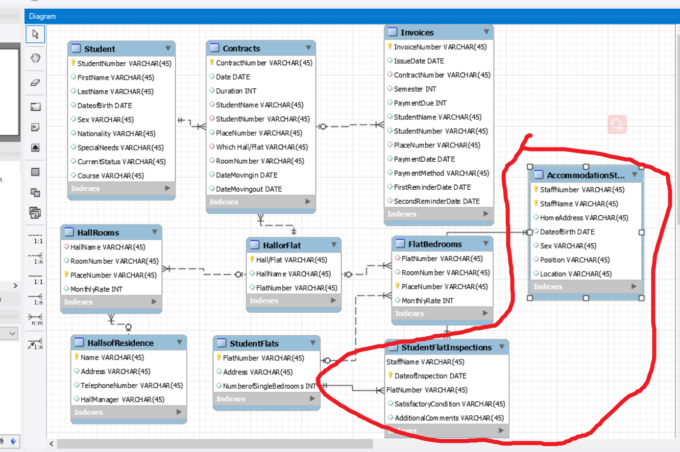

The 2 tables circled is additionally designed for **task1.**

This is the index of my tables:

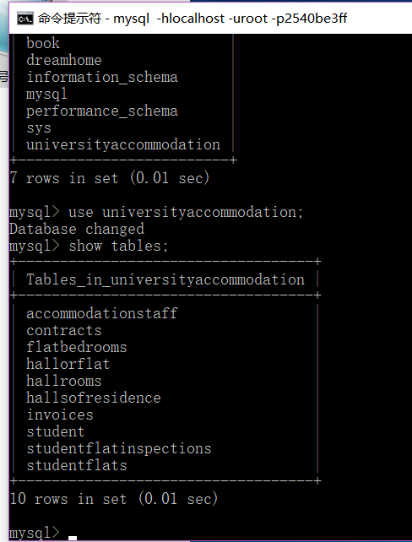

For example,the table of rooms is like this;

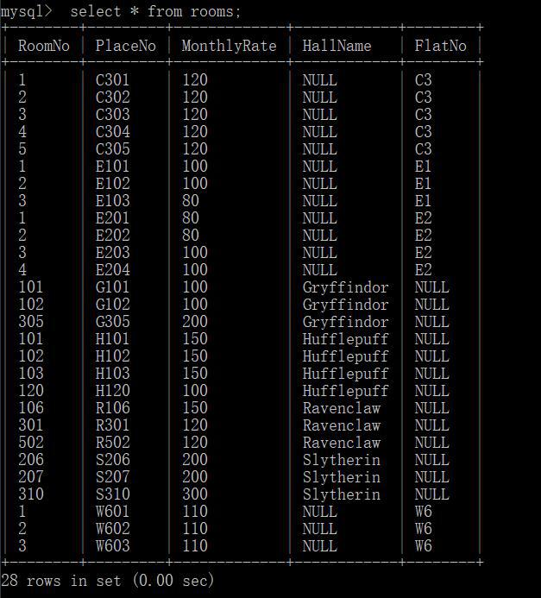

The answer code of **task2:**

INSERT INTO student

VALUES('S356','MingFei','OuYang','1999-6-24','M','China',NULL,'Waiting','IoT');

INSERT INTO contracts

VALUES('101089','2017-9-1',3,'San Zhang','S287','S310','Hall abc',123,'2017-9-5',NULL);

INSERT INTO invoices

VALUES('1108645819','2019-2-5','103523',3,400,'John','S310','S123',NULL,NULL,'2017-9-5','2019-2-20','2019-2-25');

The answer code and results of **task3:**

A.

Select contractnumber,date,duration,studentname,studentnumber,placenumber,whichhallorflat,roomnumber,datemovingin,datemovingout from Contracts

where Student s.StudentNumber=c.StudentNumber

order by s.LastName;

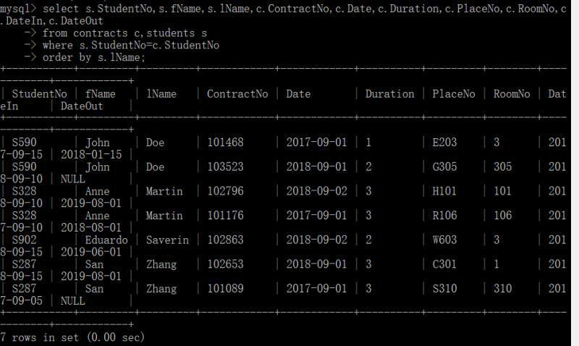

B.

select *

from contracts

where DateMovingout between "2018-06-01" and "2018-09-01";

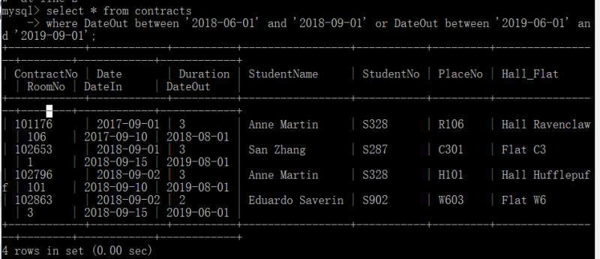

C.select count(paymentdue) from invoices

where studentname="John DOE";

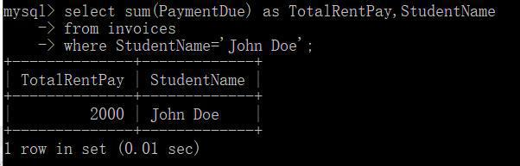

D.select *

from studentflatinspections

where SatisfactoryCondition="no";

1. select c.studentname,s.studentnumber,c.roomno,c.placeno from Students s,contracts c

Where s.studentno=c.studentno and c.HallorFlat="Hall Gryffindor";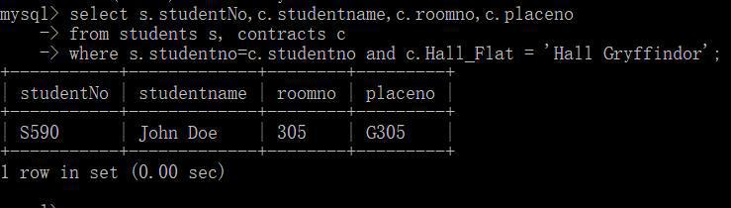

F.select min(Monthlyrate),max(Monthlyrate),avg(Monthlyrate) from Hallrooms

order by Hallname;

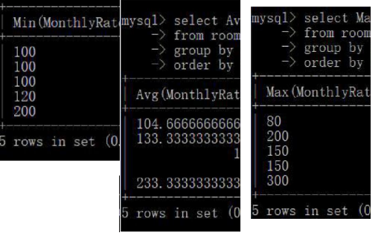

G.

select * from invoices where paymentdate is NULL;

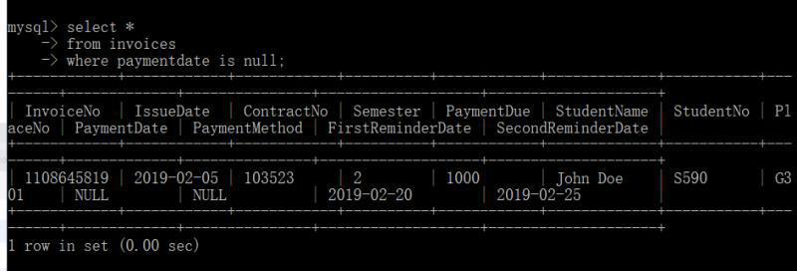

H.

select* from invoices where paymentmethod=”Cash”;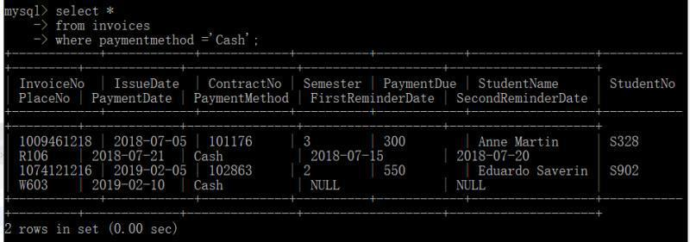

I.select sum(paymentdue) from invoices where issuedate between “2018-9-1” and “2019-8-1”;

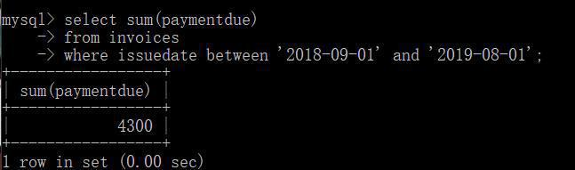

J.

Select s.studentno,n.studentname

From invoices n,students s where (paymentdate-issuedate)<10 and s.studentno=n.studentno;